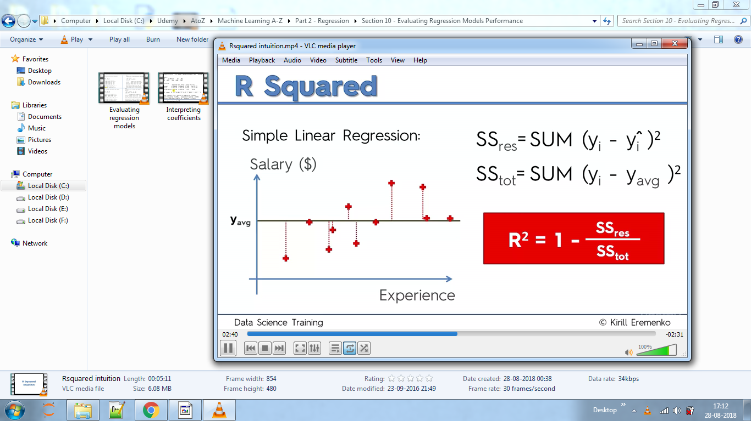

R square tell us how good is our line as compared to average value line; Ideally R squared is 1.

It signifies if by adding variable to our model, it improves our model or not.

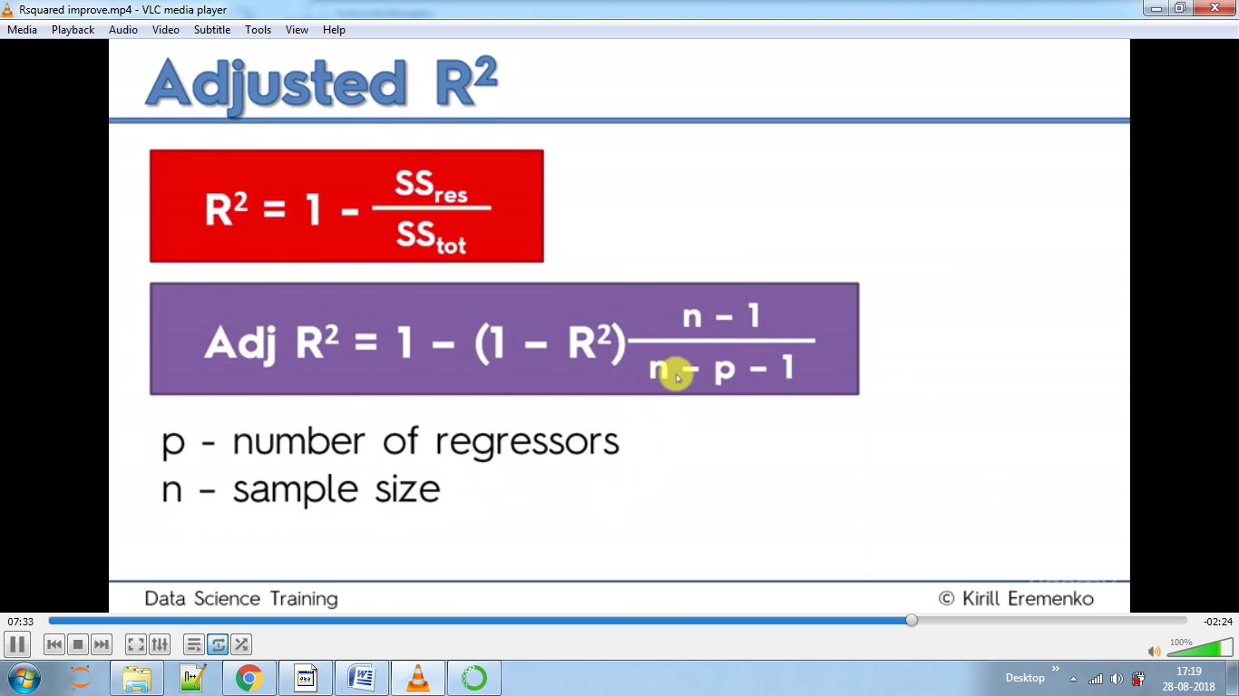

If we add one more variable to our regression model we will increase or will have no effect on Rsquared ,our Rsquare will increase always never decrease by adding variables because it picks every time even a small correlation between the dependent and other variable.

In 1st equation on adding variable, ssres increases and we try to minimise it and sstotal remain same hence r^2 increases .But in 2nd eqn we use this to improve rsquare i.e to maximise it

In equation 2 two battles are going on when we increase p, 1-r^2 increases and the factor n-1/n-p-1 decreases .If our variable is not helping, 1-r^2 will dominate and thus the value of r -square will decrease.

In Evaluating coefficients in 3rd and 4th slide we saw that backward elimination was applied but we reduce rsquared value , hence always keep on check whether rsquared value is increased or decreased.

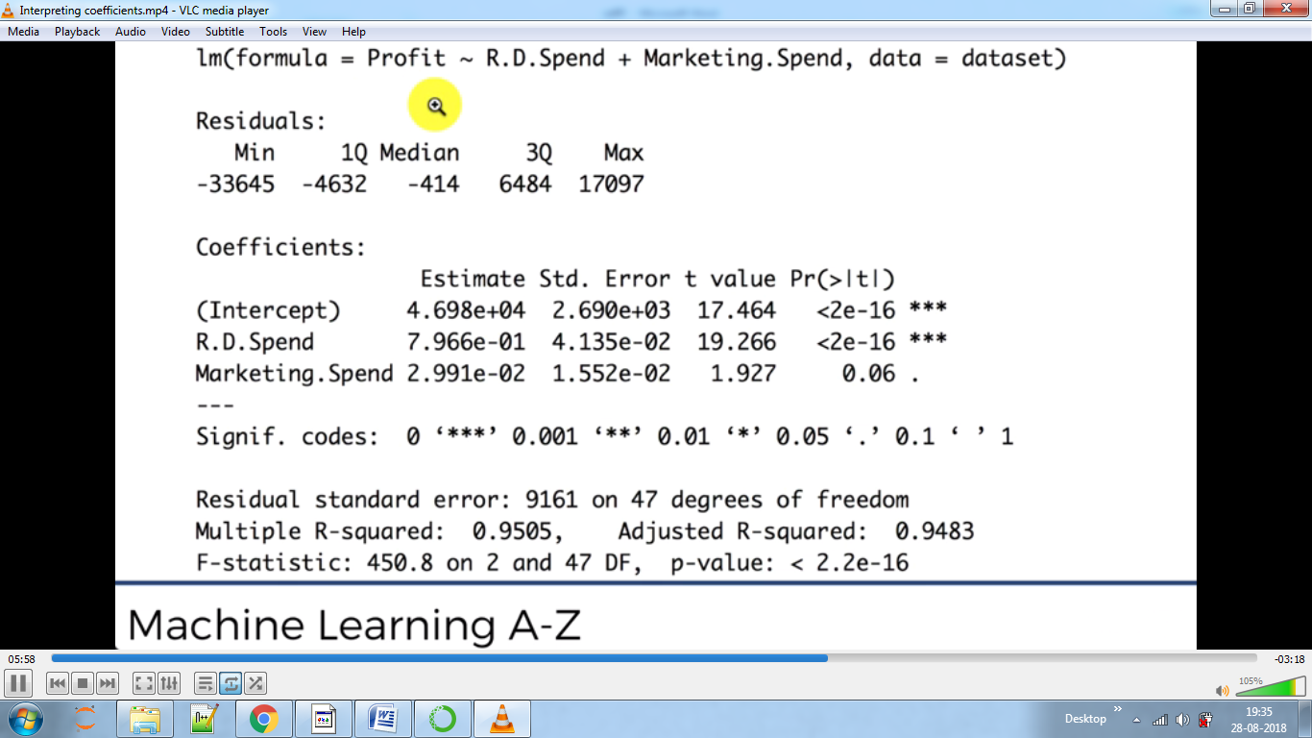

In above picture

A 1 dollar increase in RandD will increase 79cents value to the output variable.